**AIM:**

To write a program to generate the Fibonacci series using recursion.

**ALGORITHM: Fibonacci Using Recursion**

1. **Start**
2. **Define** a recursive function fibonacci(n):
   * If n == 0, return 0
   * If n == 1, return 1
   * Else, return fibonacci(n-1) + fibonacci(n-2)
3. **Input** the number of terms n to generate
4. **Repeat** for i from 0 to n-1:
   * Call fibonacci(i) and display the result
5. **End**
6. 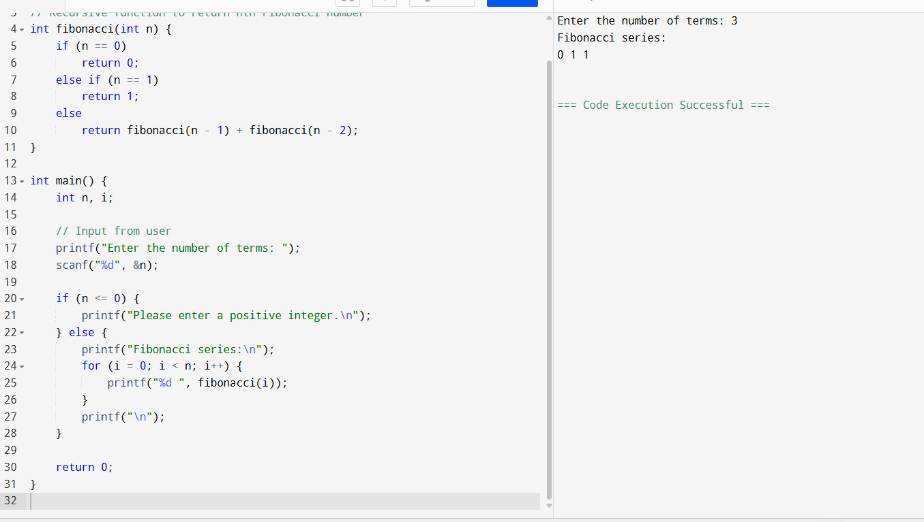

**SAMPLE OUTPUT**

1. Enter the number of terms: 7
2. Fibonacci series:
3. 0 1 1 2 3 5 8